**

Mohammad Ali Jinnah University

Chartered by Government of Sindh - Recognized by HEC

Portfolio Maker

**Subject**: Database Management System (DBMS)

**Section**: BM

**Teacher**: Rimsha Javed

**Muhamad Fahad** (FA19-BSSE-0014)

(FA19BSSE0014@maju.edu.pk)

**Ahmed Amin** (FA19-BSSE-0063)

**(**FA19BSSE0063@maju.edu.pk**)**

Business Problem

**Reason Why we need it:**

The reason we need a portfolio maker is that there are less platform that are providing a good way of making portfolio for a user to help that user in many way or even if there are some portfolio maker already exist. They are not that much better to provide every feature to fulfil their all needs.

**Key features that are provided to solve the problem:**

* The main feature is portfolio creation which help the user to make its profile & setup other things for his personal portfolio
* The basic setup such as the theme & its customization and all the looks and feel is included in this part which will make a personal to create a better portfolio for his work
* The personal setup is the thing which help the user to create the profile and setup all its information that is related to his profession, contact email and other things a user can provide which will help him in every way.
* A user can also provide the detail of his current working project and show the progress which will help him getting more and more better stakeholders who can hire that person on the basis of those project details on which he has been working or has already finished.
* A user can provide his working experience and also name the tools in which he is skillful and has worked from a long time, moreover he can provide the name of those companies where he already worked and also the time duration he has worked there.
* Other essential feature are for admin too that is like request and request generator which will generate a request from the user site to admin so that it will be approve by the admin it is one of the essential feature of the portfolio maker.

**Result we get:**

These all features are the feature that are not available in a single portfolio maker making it a better one attracting more user making it a better platform where the needs of a user is fulfilled for a better portfolio maker.

* **Identification of entities, relationships, users and their roles**
  + - **Entities**:
      * User
      * Experience
      * Skills
      * License
      * Owner
      * Information
      * Contact
      * Personal info
      * Project details
    - **Relationships**:
      * A User can change its information, Info of that user can only change by him.

**(One to One Relationship).**

* + - * A user may have different social media link, Different link belongs to a user **(One to many Relationship).**
      * A user may have different Project, Different Project belongs to a user

**(One to many Relationship).**

* + - * A user may have different Experience, Different Experience belongs to a user **(One to many Relationship).**
      * A user may have different Experience, Different Experience belongs to a user **(One to many Relationship).**
      * A user has a License key, Single License key belongs to a user

**(One to One Relationship).**

* + - * Admin can block different User through License status

**(One to Many Relationship).**

* + - **Users roles**:
      * **Guest**:
        + Can only view different Portfolio.
        + Contact with the different User.
        + Contact with the Admin.
      * **User**:
        + Can edit and view her Portfolio.
        + All the roles of guest.
      * **Admin**:
        + Can create User.
        + Can block different User.
        + All the roles of guest.
* 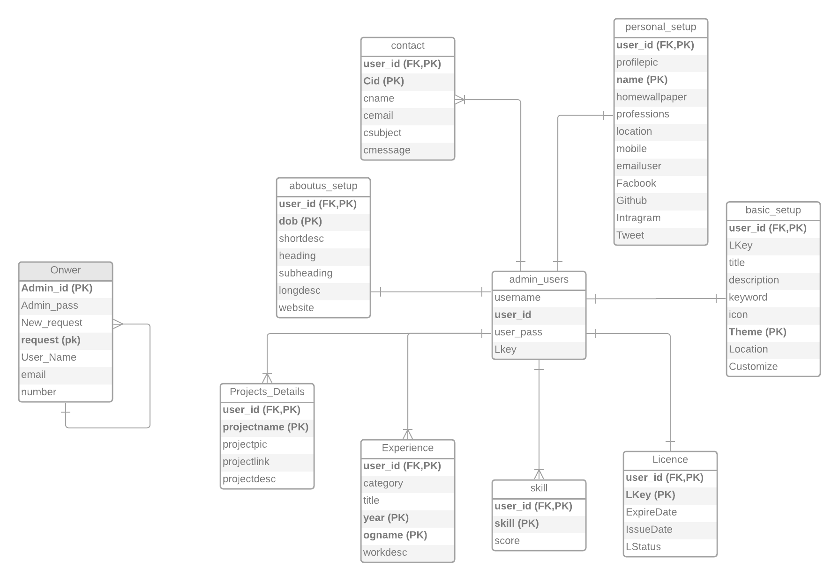**Entity Relationship Modeling (ER Diagram):**

The ER diagram need some Normalization on different table (**Owner, Personal setup, basic setup**).

* **Normalization:**

Specific table are been normalized in various steps.

1. 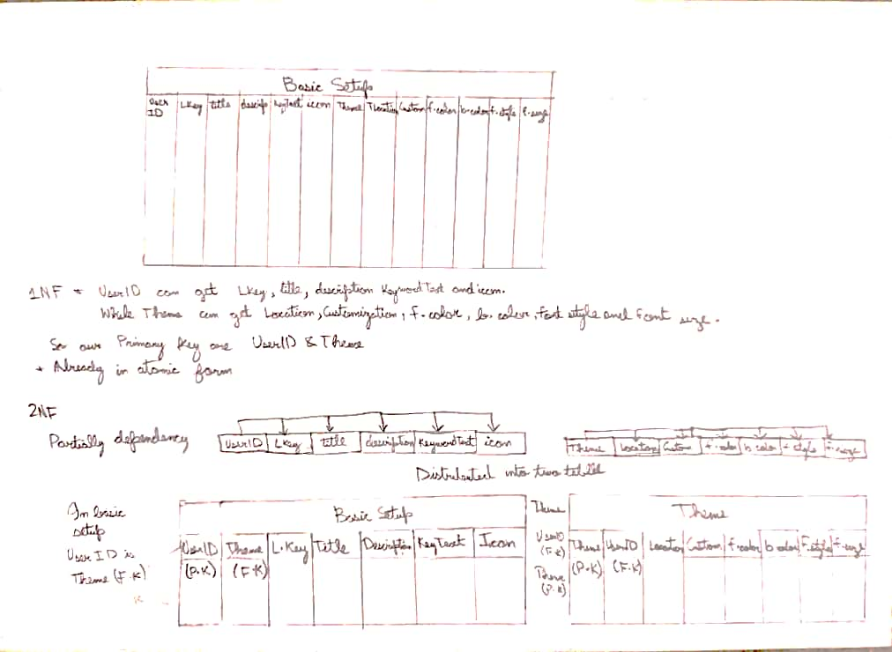**Normalization of Basic Info table:**

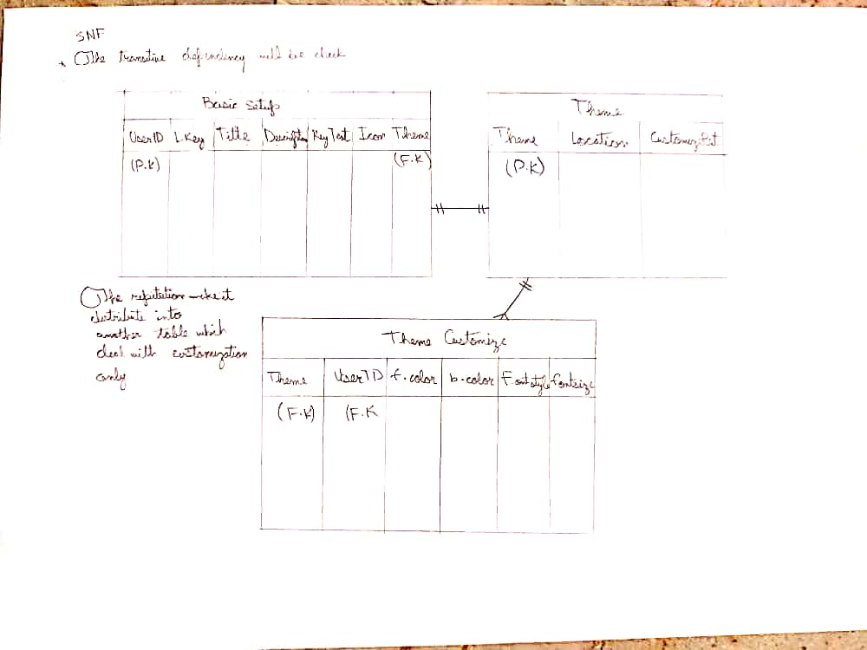

1. **Normalization of Personal Info table:**

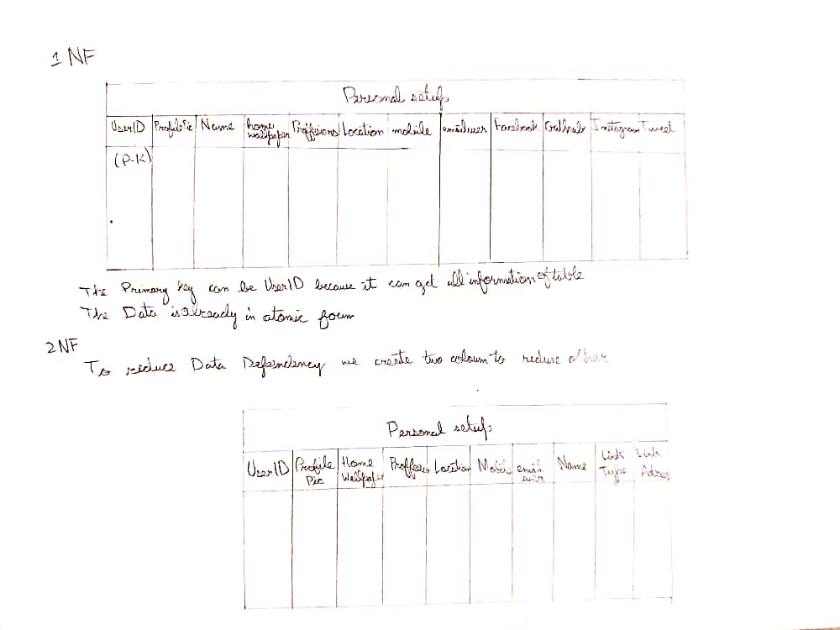

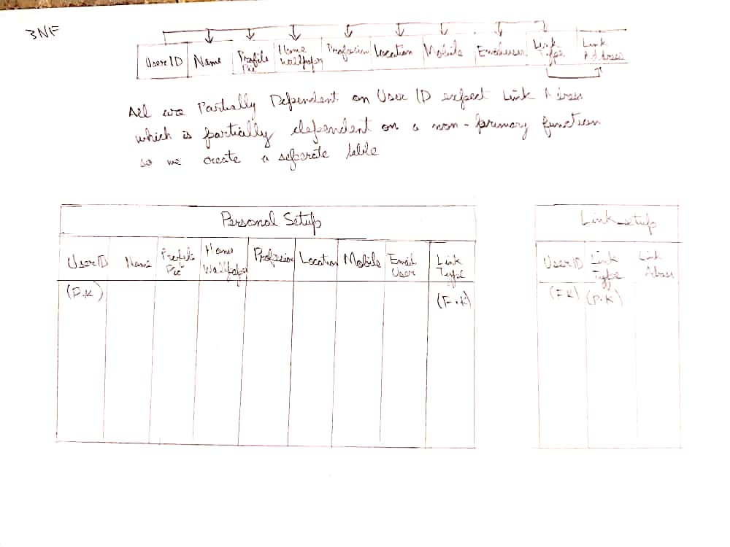

1. **Normalization of Owner table:**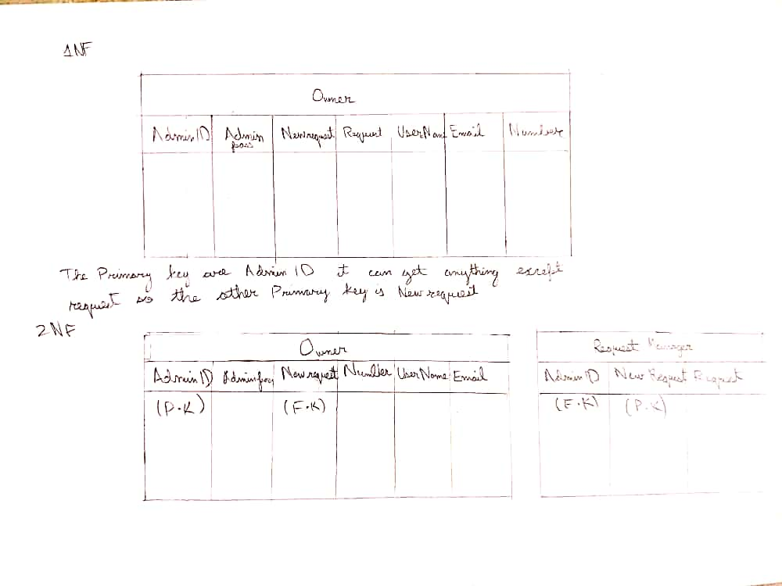

* **Finalize Entity Relationship Modeling (ER Diagram):**

